Retail Marketing Campaign Analytics Assignment

A retail company wants to analyze customer buying behavior and marketing campaign performance using Snowflake sample data.
The company has three teams:
1. Marketing Analysts
2. Finance Team
3. ETL Developers
Each team should use a separate warehouse. The company also wants to improve query performance using:
1. Warehouse scaling
2. Query result cache
3. Cluster key on customer sales date
Use Snowflake sample data from:
SNOWFLAKE_SAMPLE_DATA.TPCDS_SF10TCL.STORE_SALES
SNOWFLAKE_SAMPLE_DATA.TPCDS_SF10TCL.CUSTOMER
SNOWFLAKE_SAMPLE_DATA.TPCDS_SF10TCL.DATE_DIM
SNOWFLAKE_SAMPLE_DATA.TPCDS_SF10TCL.ITEM
________________________________________
Questions
Part 1: Warehouse Setup
Create three warehouses:
- MARKETING_WH for marketing analysts
CREATE OR REPLACE WAREHOUSE MARKETING_WH
WITH WAREHOUSE_SIZE = 'X-SMALL'
WAREHOUSE_TYPE = 'STANDARD'
AUTO_SUSPEND = 300
AUTO_RESUME = TRUE;

- FINANCE_WH for finance team
CREATE OR REPLACE WAREHOUSE FINANCE_WH
WITH WAREHOUSE_SIZE = 'X-SMALL'
WAREHOUSE_TYPE = 'STANDARD'
AUTO_SUSPEND = 300
AUTO_RESUME = TRUE;
- ETL_WH for ETL developers
CREATE OR REPLACE WAREHOUSE ETL_WH
WITH WAREHOUSE_SIZE = 'SMALL'
WAREHOUSE_TYPE = 'STANDARD'
AUTO_SUSPEND = 300
AUTO_RESUME = TRUE;
Use different warehouse sizes based on workload.
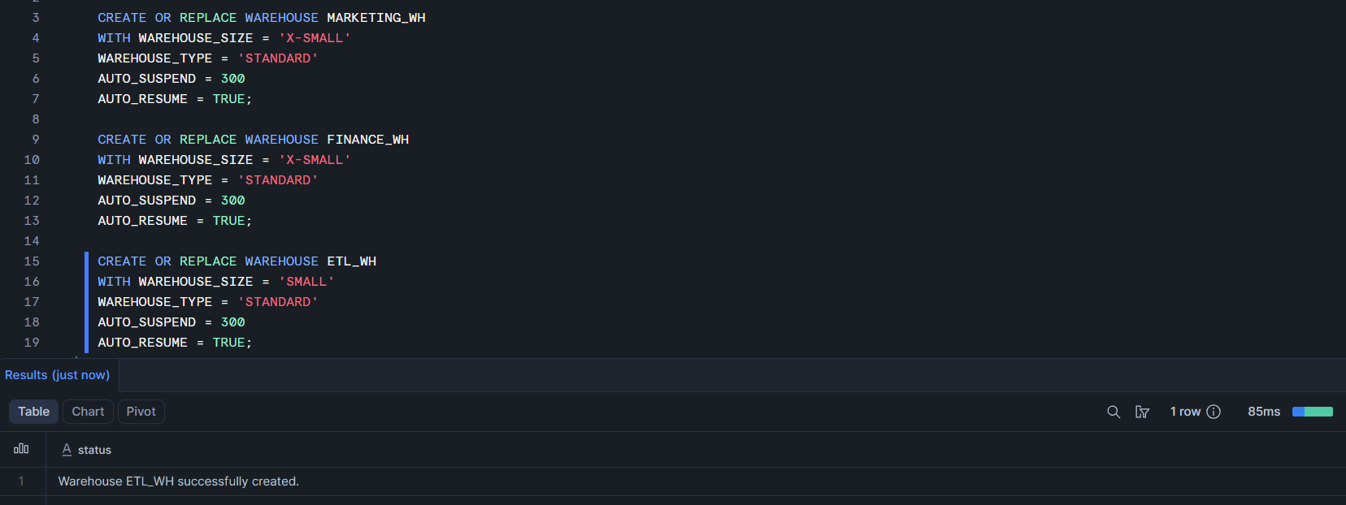

Part 2: Role Setup
Create three roles:
- MARKETING_ANALYST
CREATE OR REPLACE ROLE MARKETING_ANALYST;

- FINANCE_USER
CREATE OR REPLACE ROLE FINANCE_USER;

- ETL_DEVELOPER
CREATE OR REPLACE ROLE ETL_DEVELOPER;
Grant each role access only to its assigned warehouse.

GRANT USAGE ON WAREHOUSE MARKETING_WH TO ROLE MARKETING_ANALYST;

GRANT USAGE ON WAREHOUSE FINANCE_WH TO ROLE FINANCE_USER;

GRANT USAGE ON WAREHOUSE ETL_WH TO ROLE ETL_DEVELOPER;
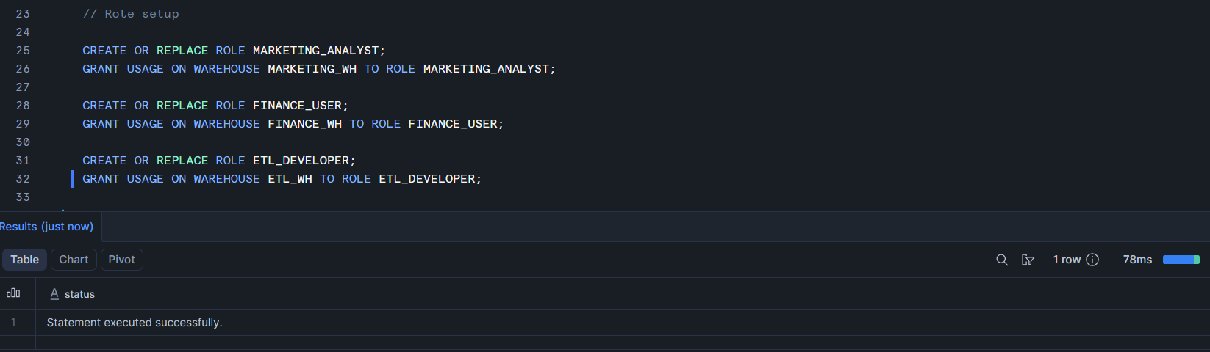

Part 3: User Setup
Create users:
- MKT_USER1

CREATE OR REPLACE USER MKT_USER1 PASSWORD = 'MKT_USER1' LOGIN_NAME = 'MKT_USER1'
DEFAULT_ROLE = 'MARKETING_ANALYST' DEFAULT_WAREHOUSE= 'MARKETING_WH' MUST_CHANGE_PASSWORD = FALSE;

- FIN_USER1

CREATE OR REPLACE USER FIN_USER1 PASSWORD = 'FIN_USER1' LOGIN_NAME = 'FIN_USER1'
DEFAULT_ROLE = 'FINANCE_USER' DEFAULT_WAREHOUSE = 'FINANCE_WH' MUST_CHANGE_PASSWORD = FALSE;

- ETL_USER1

CREATE OR REPLACE USER ETL_USER1 PASSWORD = 'ETL_USER1' LOGIN_NAME = 'ETL_USER1'
DEFAULT_ROLE = 'ETL_DEVELOPER' DEFAULT_WAREHOUSE = 'ETL_WH' MUST_CHANGE_PASSWORD = FALSE;

Set default role and default warehouse for each user.
GRANT ROLE MARKETING_ANALYST TO USER MKT_USER1;
GRANT ROLE FINANCE_USER TO USER FIN_USER1;
GRANT ROLE ETL_DEVELOPER TO USER ETL_USER1;
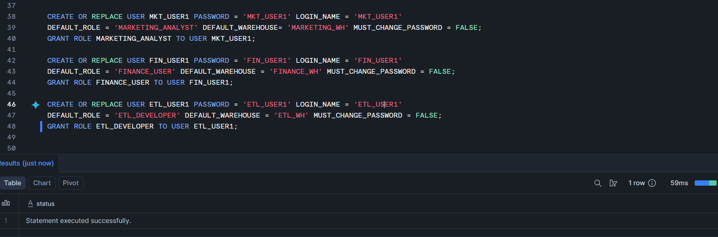

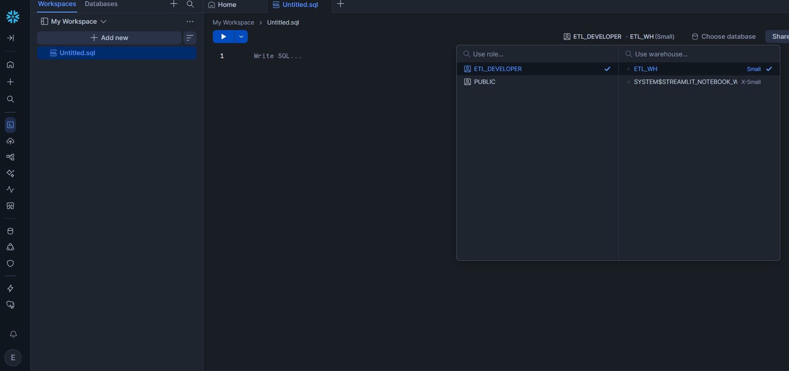
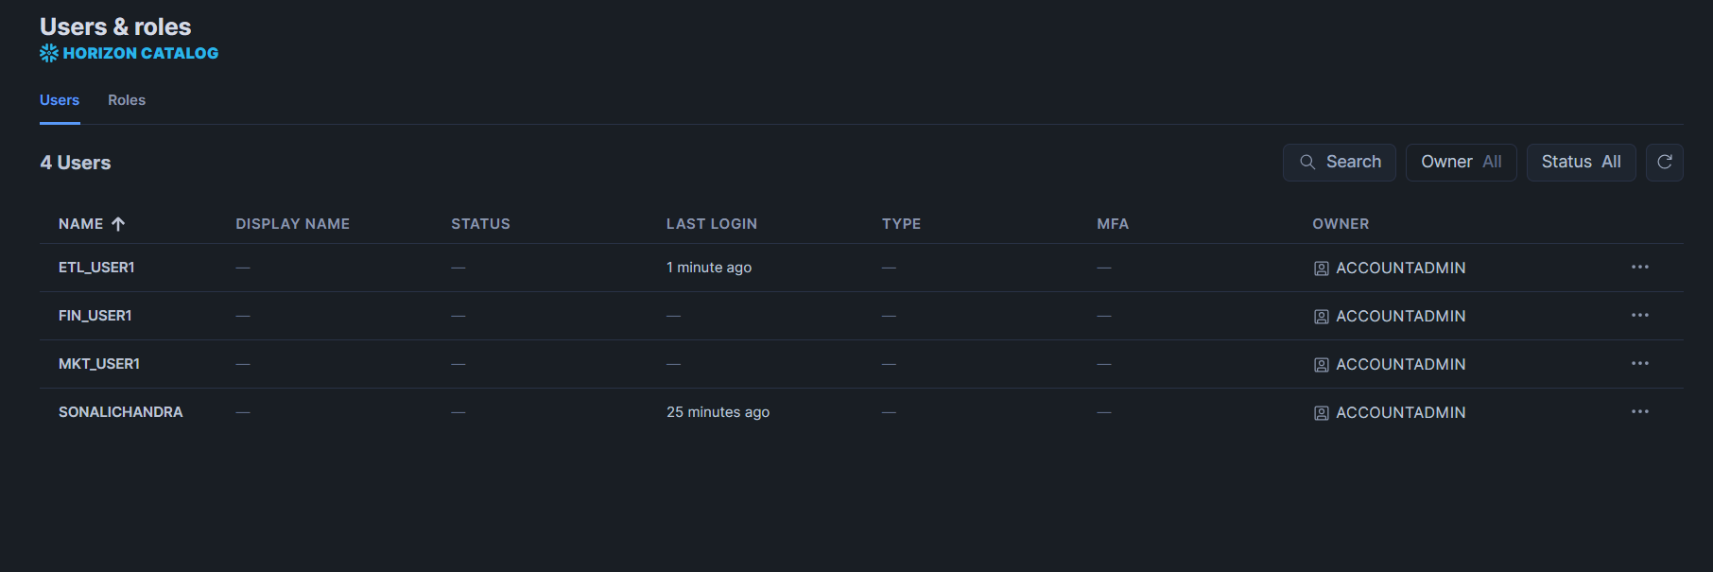
___________________________________________________________________________
Part 4: Create Performance Demo Database

Create a database called: RETAIL_MARKETING_DB
CREATE OR REPLACE DATABASE RETAIL_MARKETING_DB;

Create a table called: CAMPAIGN_SALES using Snowflake sample tables.
Understanding the 4 sample tables from Catalog to generate Campaign_sales table.
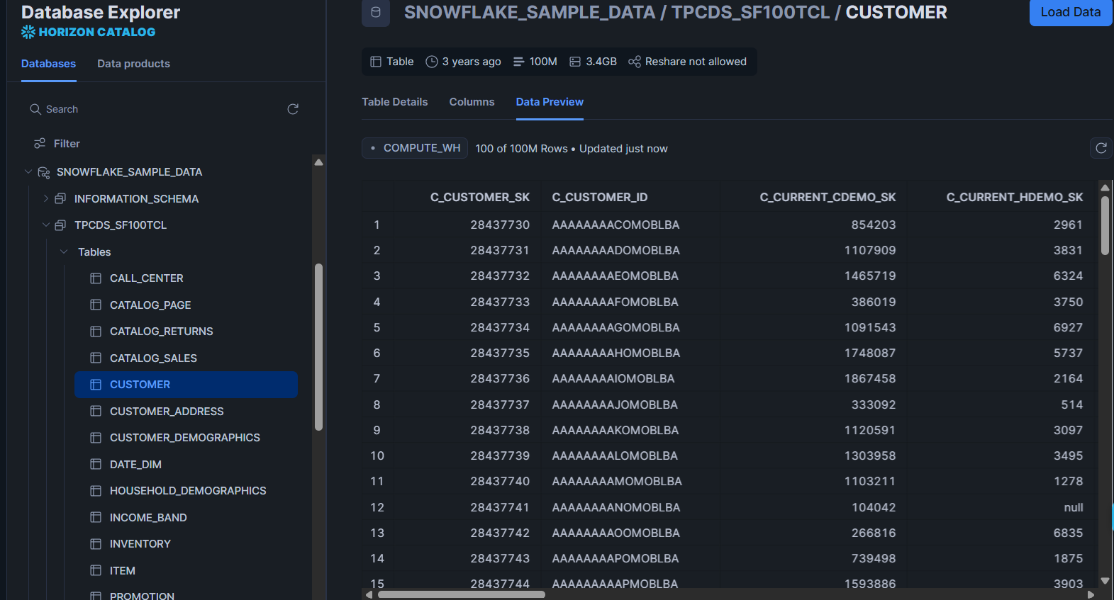

CREATE OR REPLACE TABLE RETAIL_MARKETING_DB.PUBLIC.CAMPAIGN_SALES AS
SELECT
ss.ss_customer_sk as customer_id,
ss.ss_net_paid as amount_spent,
ss.ss_quantity as quantity_sold,
ss.ss_sales_price as sales_price,

c.c_first_name as first_name,
c.c_last_name as last_name,
c.c_email_address as customer_email,
c.c_birth_year as birth_year,
i.i_item_sk as item_id,
i.i_product_name as item_name,
i.i_brand as item_brand,
i.i_class as category,

d.d_date as sale_date,
d.d_year as sale_year,
d.d_moy as sale_month

FROM SNOWFLAKE_SAMPLE_DATA.TPCDS_SF100TCL.STORE_SALES ss
JOIN SNOWFLAKE_SAMPLE_DATA.TPCDS_SF100TCL.CUSTOMER c ON ss.ss_customer_sk = c.c_customer_sk

JOIN SNOWFLAKE_SAMPLE_DATA.TPCDS_SF100TCL.ITEM i ON i.i_item_sk = ss.ss_item_sk

JOIN SNOWFLAKE_SAMPLE_DATA.TPCDS_SF100TCL.DATE_DIM d ON d.d_date_sk = ss.ss_sold_date_sk

LIMIT 100000;

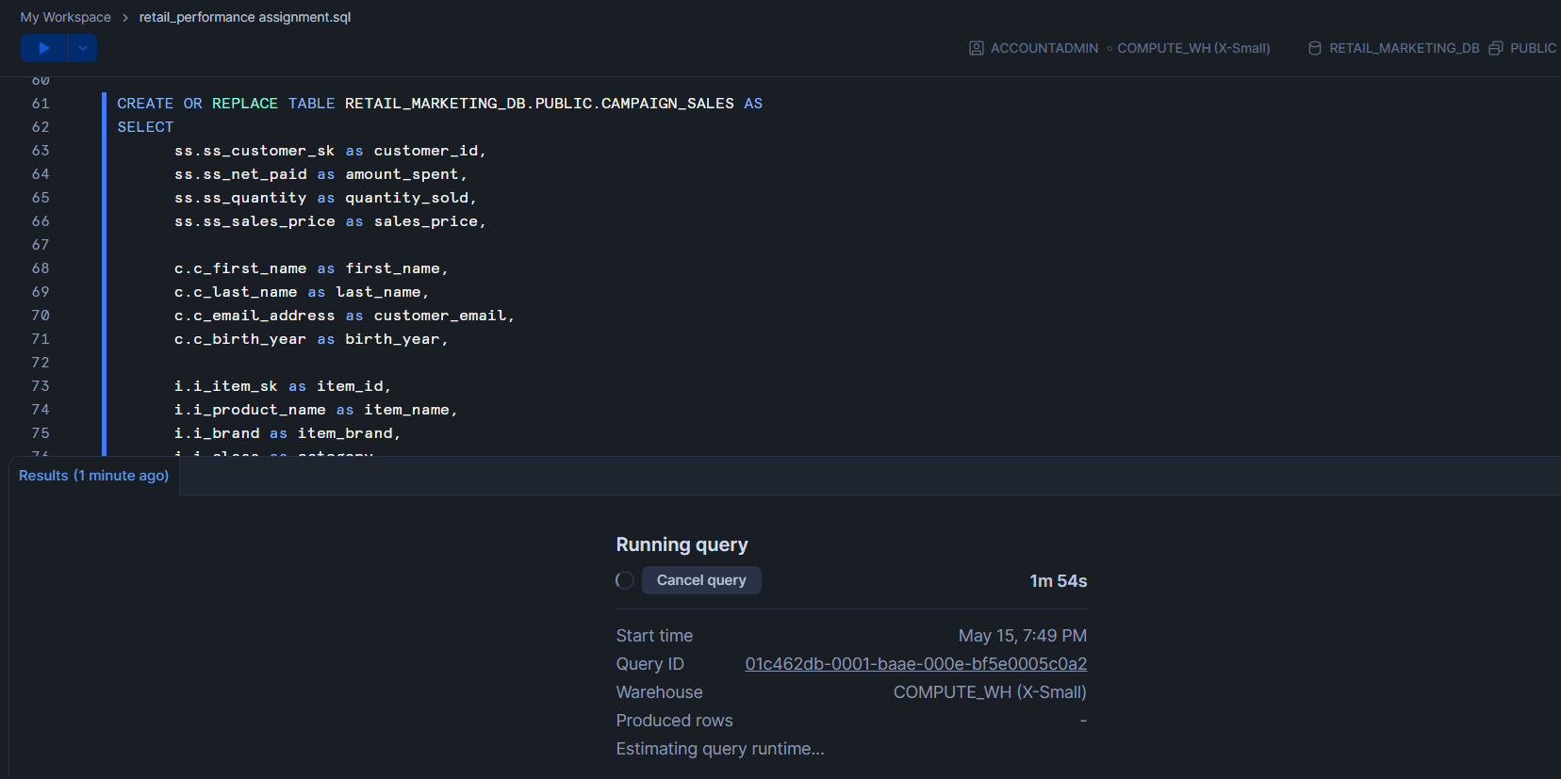
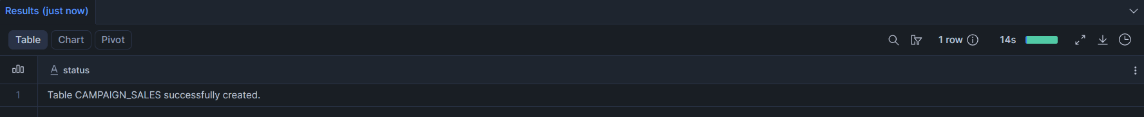

SELECT * FROM CAMPAIGN_SALES LIMIT 50;
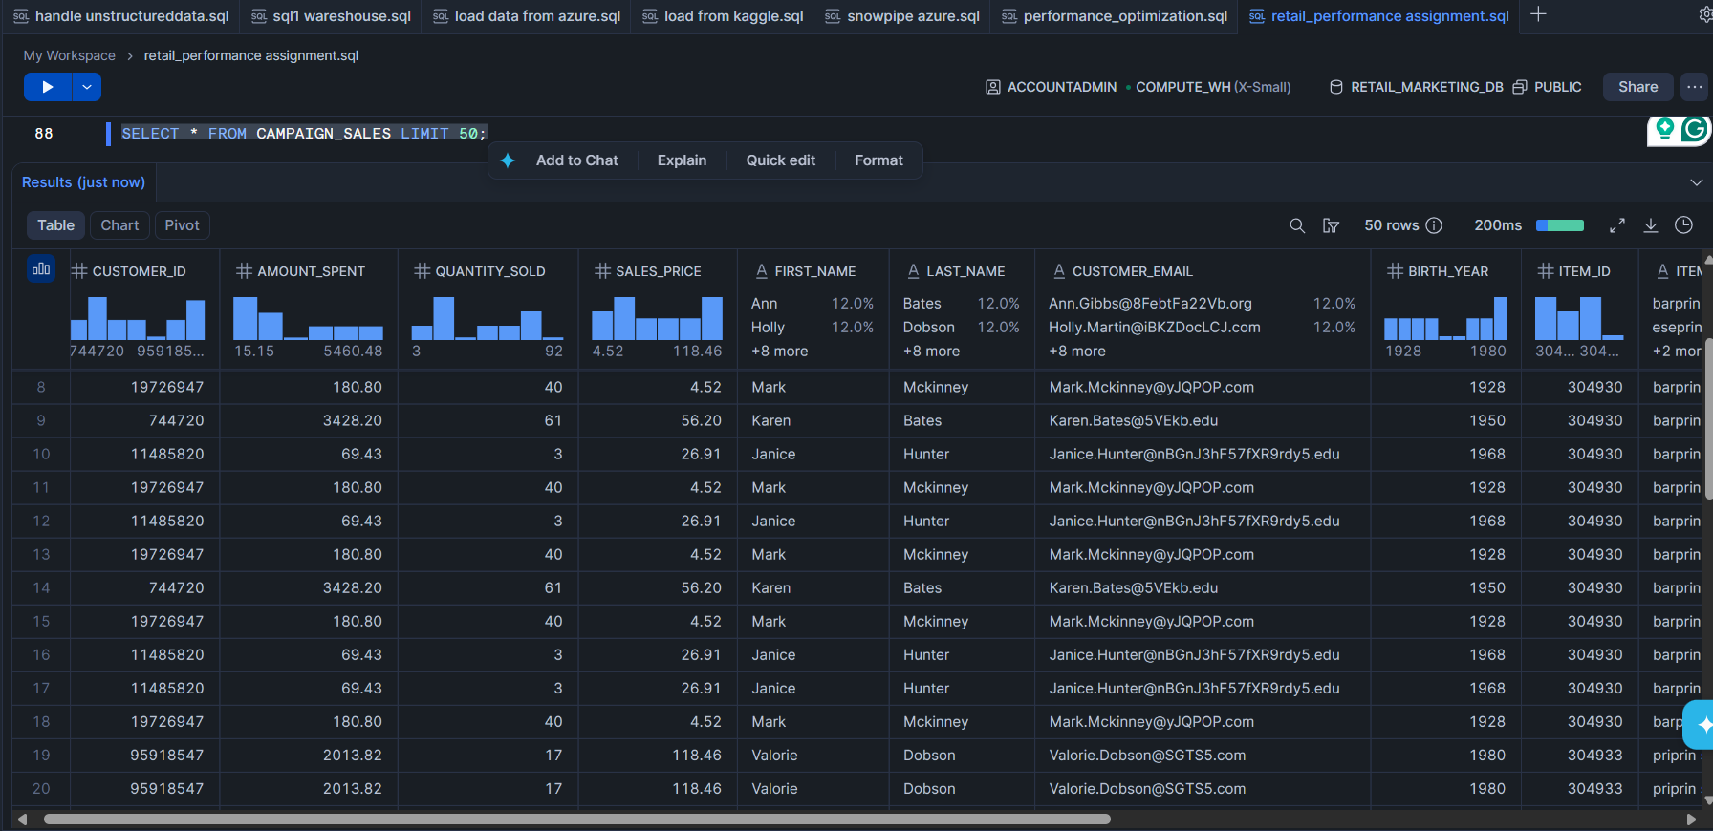
___________________________________________________________________________

Part 5: Grant Permissions
Grant proper database, schema, and table permissions to each role.
Marketing and Finance can only read data.

// To Role Marketing_Analyst
GRANT USAGE ON DATABASE RETAIL_MARKETING_DB TO ROLE MARKETING_ANALYST;
GRANT USAGE ON SCHEMA RETAIL_MARKETING_DB.PUBLIC TO ROLE MARKETING_ANALYST;
GRANT SELECT ON TABLE RETAIL_MARKETING_DB.PUBLIC.CAMPAIGN_SALES TO ROLE MARKETING_ANALYST;

// To Role Finance_User
GRANT USAGE ON DATABASE RETAIL_MARKETING_DB TO ROLE FINANCE_USER;
GRANT USAGE ON SCHEMA RETAIL_MARKETING_DB.PUBLIC TO ROLE FINANCE_USER;
GRANT SELECT ON TABLE RETAIL_MARKETING_DB.PUBLIC.CAMPAIGN_SALES TO ROLE FINANCE_USER;

ETL Developer can create and modify tables.
// To Role ETL_Developer
GRANT USAGE ON DATABASE RETAIL_MARKETING_DB TO ROLE ETL_DEVELOPER;
GRANT USAGE ON SCHEMA RETAIL_MARKETING_DB.PUBLIC TO ROLE ETL_DEVELOPER;

GRANT CREATE TABLE ON SCHEMA RETAIL_MARKETING_DB.PUBLIC TO ROLE ETL_DEVELOPER;
GRANT SELECT, INSERT, UPDATE, DELETE ON ALL TABLES IN SCHEMA RETAIL_MARKETING_DB.PUBLIC TO ROLE ETL_DEVELOPER;

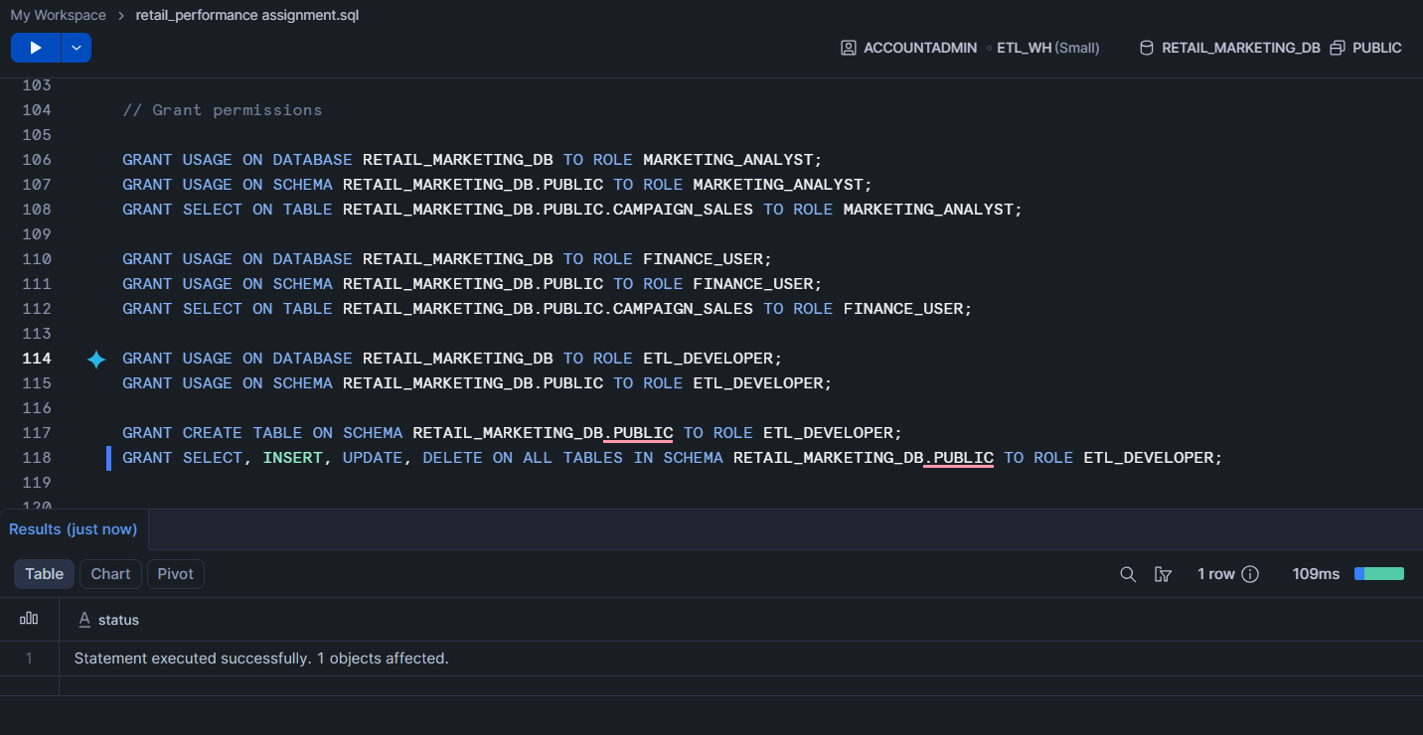

___________________________________________________________________________

Part 6: Performance Testing

Run a sales analysis query using XSMALL warehouse.
SELECT SALE_YEAR, CATEGORY, SUM(QUANTITY_SOLD) AS TOTAL_QUANTITY_SOLD, SUM(AMOUNT_SPENT) AS AMOUNT
FROM CAMPAIGN_SALES GROUP BY SALE_YEAR, CATEGORY
ORDER BY SALE_YEAR, TOTAL_QUANTITY_SOLD;

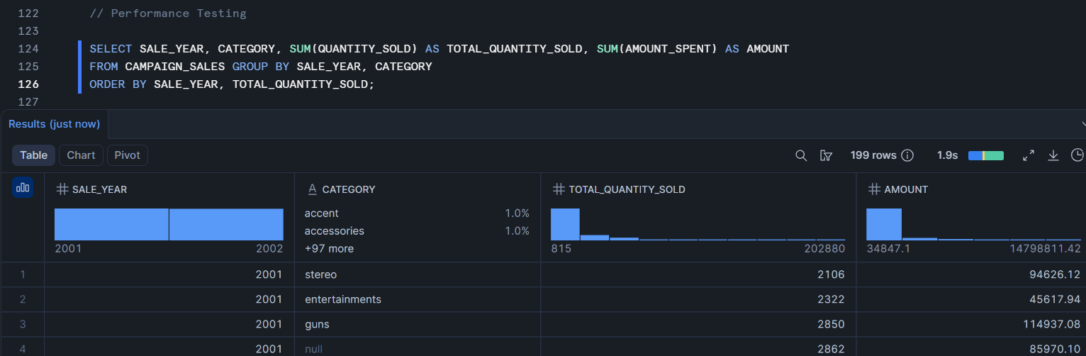
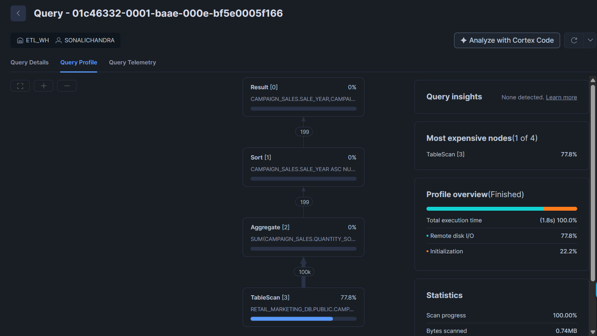

Then scale up the warehouse to SMALL.
ALTER WAREHOUSE MARKETING_WH
SET WAREHOUSE_SIZE = 'SMALL';
Compare performance
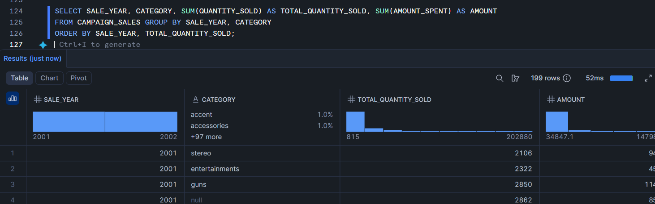
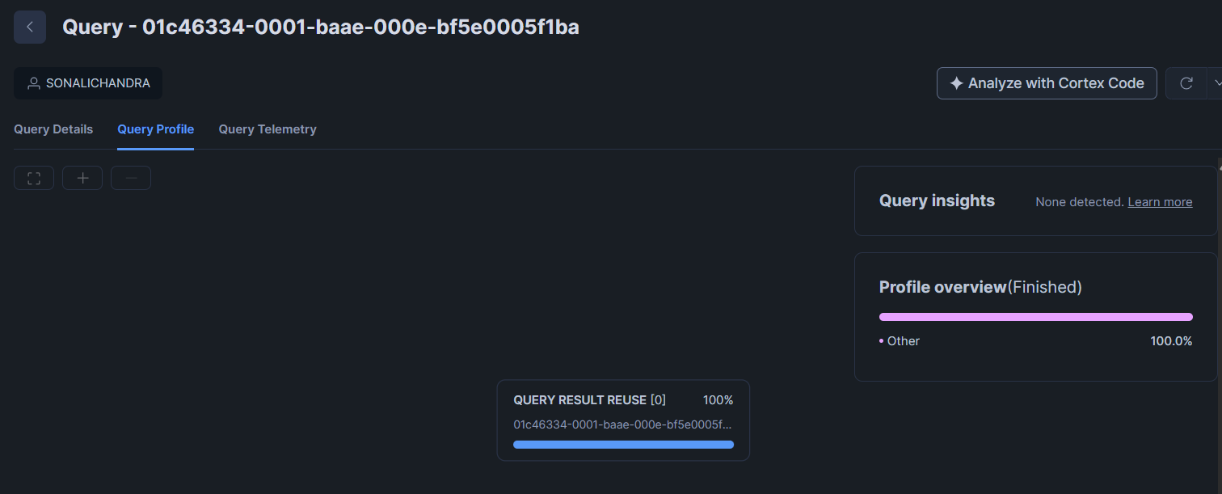

Warehouse with X-Small size computed and executed the query in 1.9s, while the warehouse with Small size resulted in 52ms.
X-Small WH performed Table scan, aggregation, sorting and then gave result.
While Small WH simply gave result by using the cached memory.

Then scale it down again.
ALTER WAREHOUSE MARKETING_WH SET WAREHOUSE_SIZE = 'X-SMALL';
___________________________________________________________________________

Part 7: Cache Testing
Run the same query twice.
Observe why the second query is faster.

SELECT * FROM CAMPAIGN_SALES WHERE CATEGORY != 'optics';
First Execution: Took 232ms
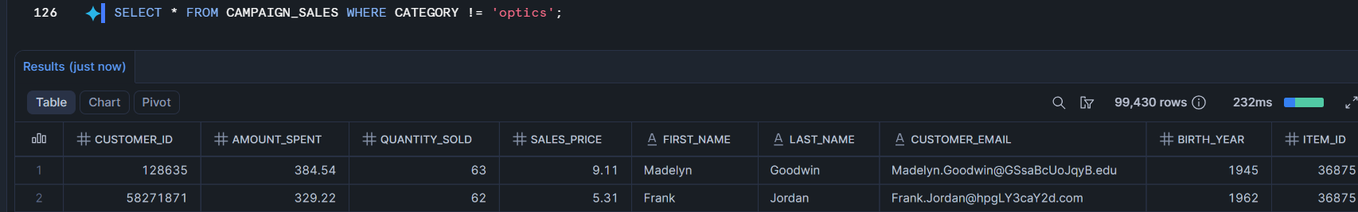
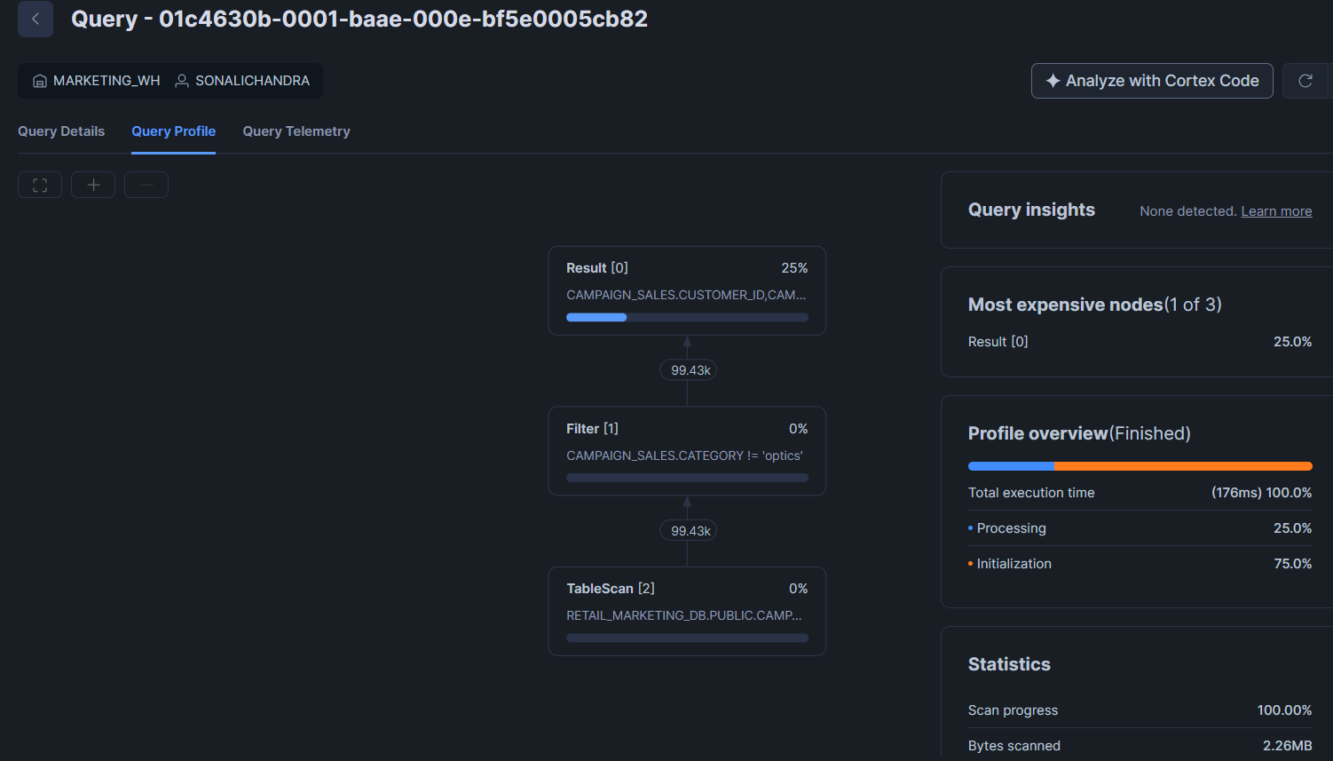

Second Execution: Took 37ms
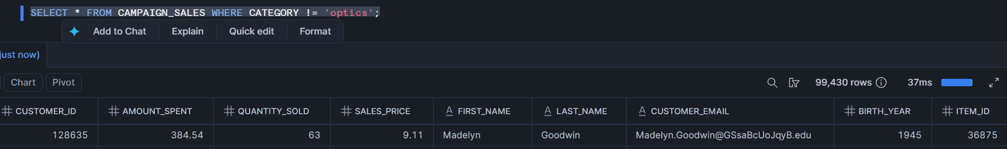
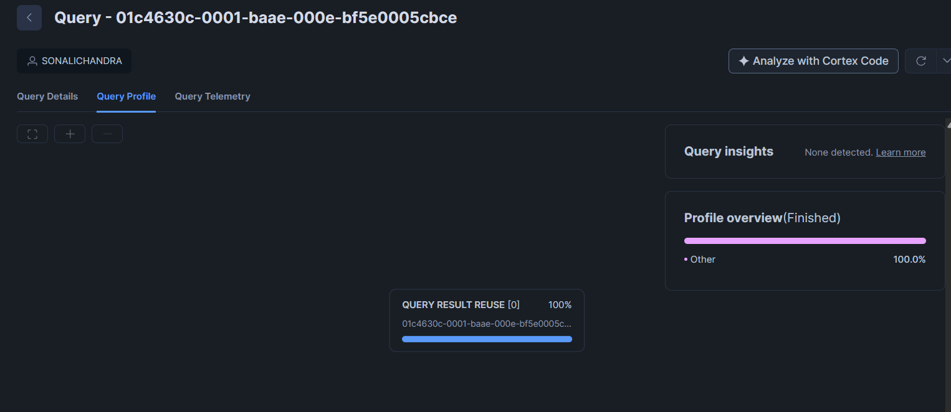
The second execution runs faster because the query remain unchanged, the user and role are also unchanged, thus the query result was stored in cache. The virtual warehouse compute did not have to re-execute the query entirely.
___________________________________________________________________________

Part 8: Cluster Key Testing
Run a date-filter query before clustering.
SELECT * FROM CAMPAIGN_SALES WHERE SALE_DATE BETWEEN '2000-01-01' AND '2020-01-31';
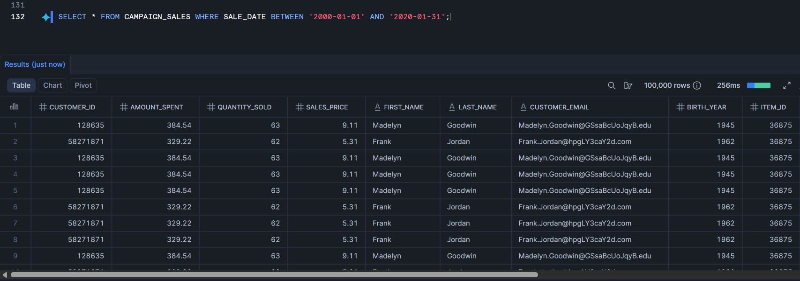

Add cluster key on SALE_DATE.
ALTER TABLE CAMPAIGN_SALES CLUSTER BY (SALE_DATE);

Run the same query again.
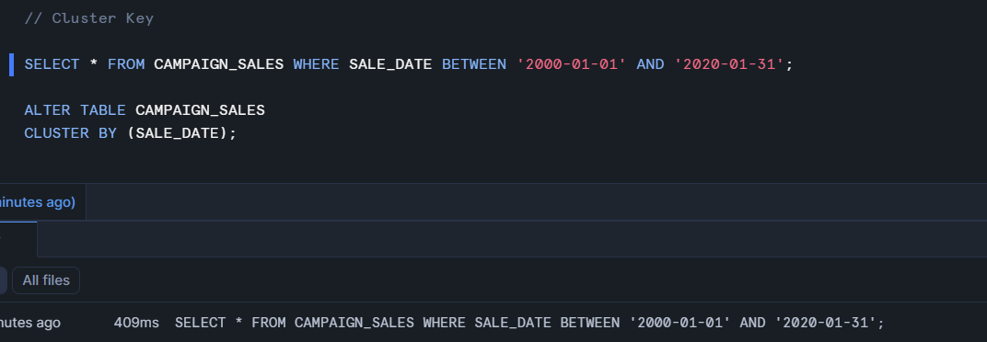

Compare performance.

WITHOUT CLUSTER KEY
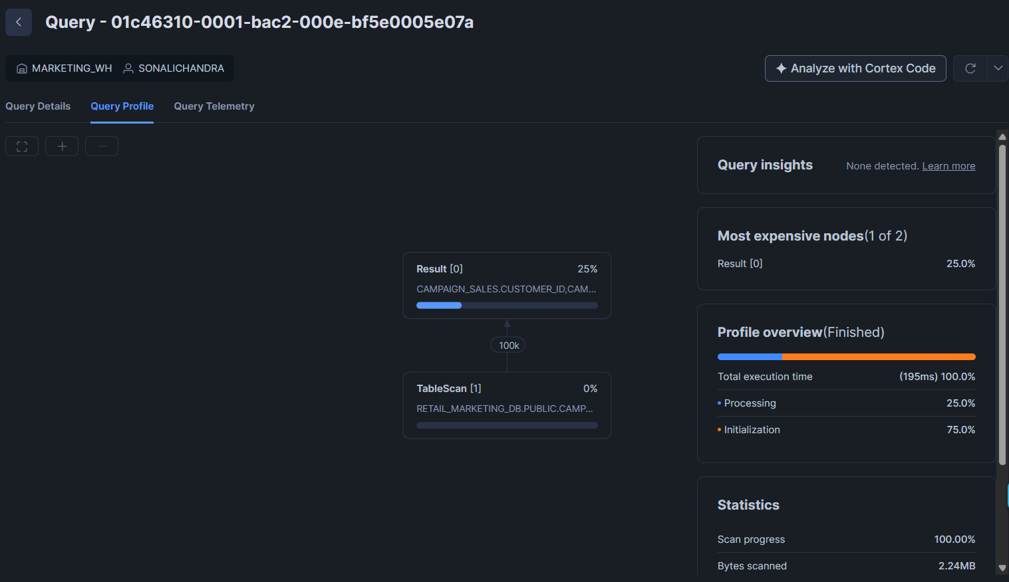

WITH CLUSTER KEY
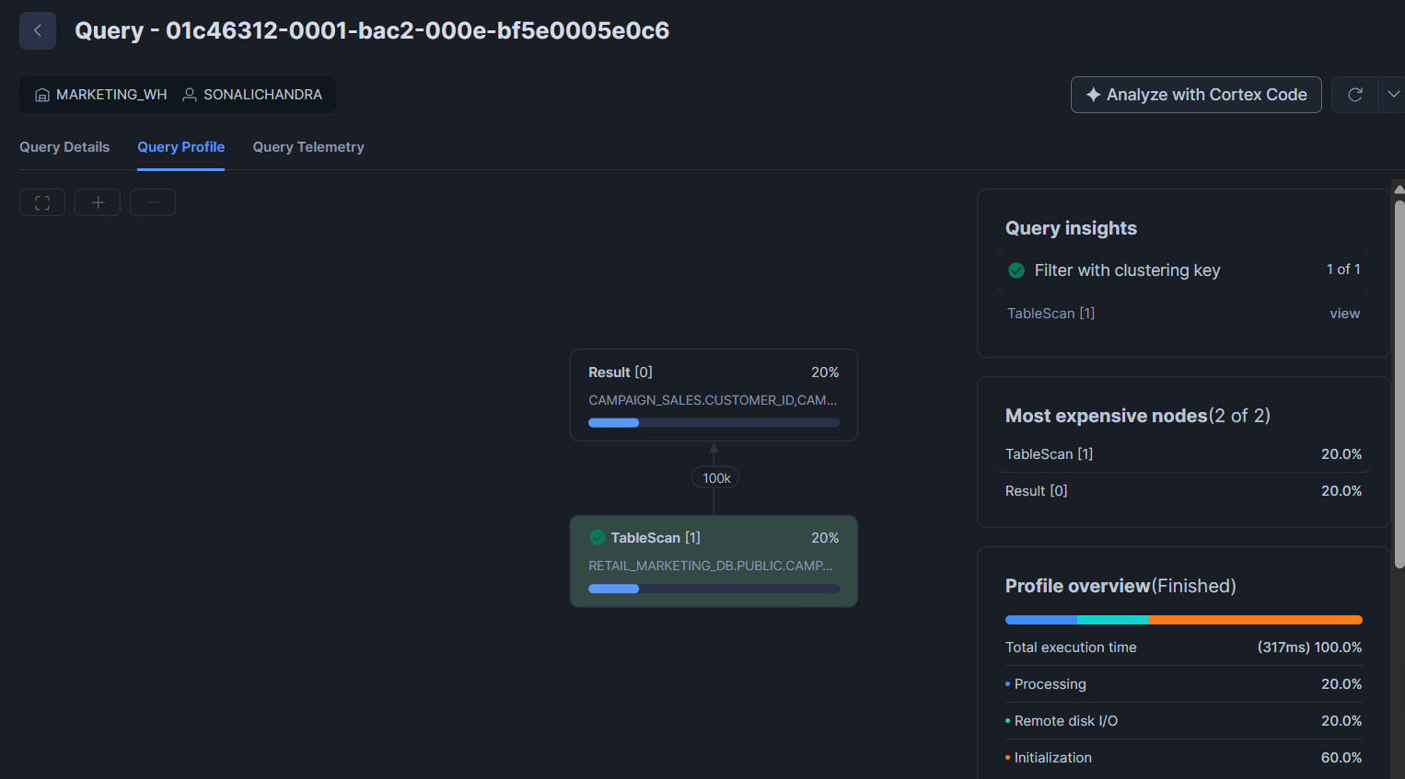
Scanning of all the data using partition.

